UNIVERSITY TIMETABLE OPTIMIZATION
AND MANAGEMENT SYSTEM (UTOS)
Software Engineering Project Document
Full-Scope Analysis: Requirements, Use Cases, System Modeling, and UI Evidence
Version 3.0 | May 2026
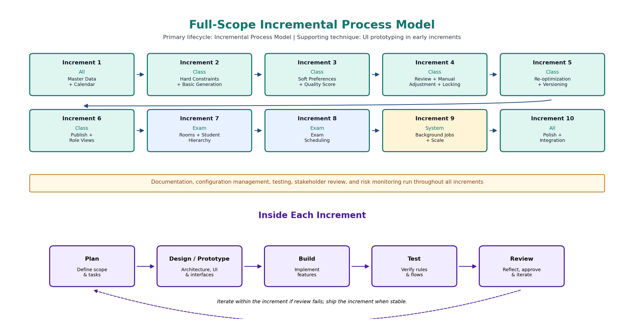
Figure 1: Full-scope incremental process model used as the revised development baseline.

Document Contents
- 1. Introduction and Scope Alignment
- 2. Process Model
- 3. Requirements Summary from Full-Scope SRS
- 4. Use Case Analysis Approach
- 5. Actors, Goals, and System Boundary
- 6. High-Level Use Case Summary
- 7. Expanded Use Cases: Essential and Real
- 8. Updated Use Case Diagrams
- 9. System Modeling and Diagram Review
- 10. UI Screenshots and Real Use Case Evidence
- 11. Traceability Matrix
- 12. Final Modeling Notes, Conclusion, and Checklist
This revised document upgrades the earlier class-timetable report into a full-scope Software Engineering project document. It aligns the analysis with the complete SRS, applies the teacher-provided Analysis Models format, and connects abstract requirements to concrete UTOS prototype screens.

1. Introduction and Scope Alignment

1.1 Purpose
This document is the Software Engineering project report for the University Timetable Optimization and Management System (UTOS). It records the project requirements, process model, use case analysis, system modeling, and UI evidence for a university-level SE submission.

1.2 System Overview
UTOS is a web-based platform for creating, optimizing, reviewing, repairing, publishing, and reporting university timetables. The full-scope version contains two related scheduling subsystems: a Class Timetabling Module and an Exam Timetabling Module. Both share system-wide services such as authentication, role-based access, notifications, exports, version comparison, reports, audit logging, and user management.
- Class Timetabling: weekly class generation, conflict detection, quality review, manual adjustment, locking, re-optimization, versioning, publication, and role-filtered views.
- Exam Timetabling: exam rooms, student hierarchy, course-exam association, semi-automatic exam placement, no double-booking, invigilation duties, and exam export.
- System-Wide Services: login, roles, sessions, notifications, export, version comparison, audit, reports, and user administration.

1.3 Problem Statement
Manual timetable preparation at university scale is slow, error-prone, and difficult to update. Class scheduling must avoid teacher, room, and section clashes while respecting availability, room capacity, holidays, durations, and institutional preferences. Exam scheduling must avoid student double-booking and room double-booking while handling room capacity and invigilation duties. UTOS addresses these problems through validated master data, configurable constraints, solver-based scheduling, human review, and controlled publication.

1.4 Scope Alignment
Scope Area | Included? | Reason
Class Timetabling | Yes | Core weekly timetable generation, repair, publication, and reporting.
Exam Timetabling | Yes | Full SRS includes exam rooms, student hierarchy, exam courses, exam placement, invigilation, and exports.
System-Wide Features | Yes | Authentication, role-based access, export, notifications, version comparison, audit logs, and user management.
Out-of-Scope Items | Documented only | Fees, hostel allocation, attendance, full ERP, deep algorithm benchmarking, and multi-campus simulation are not v1.0 features.

2. Process Model

2.1 Selected Lifecycle
The primary lifecycle is the Incremental Process Model with Prototyping as a supporting technique. This is academically appropriate because UTOS can be delivered in meaningful increments, while early UI prototypes help validate screens and workflows before full implementation. Prototyping is therefore a validation technique inside early increments, not a second primary process model.

2.2 Planned Increments
Increment | Module | Focus | User-Visible Value
1 | All | Master Data + Academic Calendar | Core data becomes maintainable.
2 | Class | Hard Constraints + Basic Generation | First clash-aware draft is produced.
3 | Class | Soft Preferences + Quality Scoring | Admin can tune and evaluate quality.
4 | Class | Review + Adjustment + Locking | Admin can repair and preserve entries.
5 | Class | Re-optimization + Versioning | Approved changes are repaired with minimal disruption.
6 | Class | Publish + Role Views | Teachers and students see official schedules.
7 | Exam | Room Management + Student Hierarchy | Exam data foundations are prepared.
8 | Exam | Exam Scheduling | Exam sessions are suggested and confirmed.
9 | System | Background Jobs + Scale | Long operations run without blocking UI.
10 | All | Polish + Integration | Exports, notifications, audit, reports, and UI consistency are finalized.

Figure 2: Updated full-scope incremental process model with ten increments.

3. Requirements Summary from Full-Scope SRS
The following requirement summary is used to keep the use cases traceable to SRS v1.0. Detailed requirement identifiers are listed again in the expanded use cases and traceability matrix.
Module | Requirement Group | Summary
System-Wide | Authentication and Login | Role-based login, sessions, logout, password reset, and profile view.
System-Wide | Organization, Export, Notifications, Versioning | University hierarchy, term versions, PDF/Excel/CSV export, notification history, and version comparison.
Class | Calendar, Master Data, Constraints | Semester dates, holidays, teachers, rooms, sections, courses, durations, timeslots, hard constraints, and soft preferences.
Class | Generation, Review, Repair, Publish | Background generation, conflict reports, quality scoring, manual adjustment, locked entries, re-optimization, one published timetable per term, and role views.
Exam | Exam Scheduling | Rooms, building distance, student hierarchy, exam courses, suggestions, confirmation, no double-booking, invigilation, and exam exports.
Administration | Reports and Audit | Room utilization, teacher load, conflict summaries, quality reports, action history, and audit logs.

4. Use Case Analysis Approach
Use cases are written from actor goals. A high-level use case provides a short goal-level description. An expanded use case is fully dressed and includes purpose, overview, preconditions, postconditions, typical course of events, alternatives, and special requirements. Essential use cases remain abstract and technology-free. Real use cases describe the current UTOS UI behavior using the supplied screenshots.
Concept | Meaning
High-Level Use Case | Brief actor-goal description with scope, actor, and goal.
Expanded Use Case | Detailed narrative with actor actions, system responses, alternatives, and SRS references.
Essential Use Case | Abstract, implementation-independent description of the user intention.
Real Use Case | Concrete UI-based description connected to prototype screenshots.
Modeling Note | Business order such as review before publish is documented in flows, not forced into incorrect UML include/extend relations.

5. Actors, Goals, and System Boundary
Actor | Core Goal
Timetable Administrator | Maintain data, define rules, generate and review timetables, lock entries, re-optimize, publish, export, and view reports.
Department Coordinator | Validate department data, review schedules, approve/reject change requests, and monitor teacher/section load.
Teacher | View personal timetable, submit availability or change requests, and view invigilation duties.
Student | View published section timetable and exam schedule.
Facility Manager | Maintain room data and review room utilization, capacity, and availability reports.
System Administrator | Manage user accounts, roles, permissions, backups, and audit/security controls.

6. High-Level Use Case Summary
ID | Use Case | Module | Primary Actor | Goal
UC00 | Authenticate and Login | System-wide | All users | Access UTOS through role-aware authentication and maintain a valid session.
UC01 | Maintain Organization Hierarchy | System-wide | System Administrator | Maintain University, Faculty, Department, Batch, Section, and academic term structure.
UC02 | Maintain Academic Calendar | Class | Timetable Administrator | Record semester dates, working days, holidays, blackout dates, and makeup policies.
UC03 | Manage Master Data | Class/System | Timetable Administrator | Maintain teachers, rooms, courses, sections, timeslots, buildings, and room features.
UC04 | Define Constraints and Preferences | Class | Timetable Administrator | Configure hard rules and weighted soft preferences used by the solver.
UC05 | Generate Class Timetable | Class | Timetable Administrator | Produce a draft weekly class timetable from data, constraints, and preferences.
UC06 | Review Timetable Quality | Class | Timetable Administrator | Inspect conflicts, unplaced sessions, quality score, room utilization, and teacher load.
UC07 | Manually Adjust and Lock Timetable | Class | Timetable Administrator | Modify entries and protect selected assignments from automatic changes.
UC08 | Submit Change Request | Class | Teacher / Department Coordinator | Submit a formal request to change a timetable entry.
UC09 | Approve or Reject Change Request | Class | Department Coordinator / Timetable Administrator | Review request details and approve, reject, or return the request.
UC10 | Re-optimize Timetable | Class | Timetable Administrator | Repair the timetable after approved changes while minimizing disruption.
UC11 | Publish Timetable | Class | Timetable Administrator | Release the approved timetable as the official schedule for a term.
UC12 | View Personal or Section Timetable | Class | Teacher / Student | View a role-filtered timetable with day, time, course, teacher, and room details.
UC13 | Export Timetable | System-wide | Authorized user | Export class or exam schedules to PDF, Excel, or CSV.
UC14 | Manage Notifications | System-wide | All users | Receive and view notifications related to generation, publication, changes, and versions.
UC15 | Compare Timetable Versions | System-wide | Timetable Administrator | Compare two timetable versions and review added, removed, or changed entries.
UC16 | Manage Exam Rooms | Exam | Timetable Administrator / Facility Manager | Maintain exam rooms, capacity, type, and optional building distance information.
UC17 | Manage Student Hierarchy | Exam | Timetable Administrator / Department Coordinator | Maintain University-to-Student hierarchy for exam scheduling.
UC18 | Manage Exam Courses | Exam | Timetable Administrator | Associate courses with exams, durations, and taking sections.
UC19 | Schedule Exams | Exam | Timetable Administrator | Generate or confirm exam placements without double-booking students or rooms.
UC20 | View Exam Schedule and Invigilation Duties | Exam | Student / Teacher | View exam timetable and assigned invigilation duties.
UC21 | Manage Users and Roles | Administration | System Administrator | Create accounts, assign roles, enforce access, and support bulk import.
UC22 | View System Reports and Audit Logs | Administration | Timetable Administrator / Facility Manager / System Administrator | View utilization, load, conflicts, quality, and audit history reports.

7. Expanded Use Cases: Essential and Real
The complete system has twenty-three high-level use cases. The most important end-to-end and risk-bearing use cases are expanded below. The remaining use cases are covered by the high-level catalog, diagrams, requirements summary, and traceability matrix.

UC00 - Authenticate and Login
Field | Detail
Scope | University Timetable Optimization and Management System (UTOS)
Level | User-goal level
Primary Actor | All users
Module | System-wide
Purpose | Authenticate users and open a role-appropriate UTOS session.
Preconditions | Actor is authenticated and authorized; required reference data exists for this use case.
Postconditions | Result is stored, visible to authorized users, and audit/notification records are created where required.
SRS Cross Reference | FR-00.1 to FR-00.6c
Related UI Evidence | See Section 10 UI Evidence Gallery where applicable.

Essential Course of Events
Step | Actor Action | System Response
1 | This use case begins when a user requests access to UTOS. | The system presents role-aware login options.
2 | The user provides credentials. | The system verifies identity and permissions.
3 | The user confirms login. | The system opens the correct dashboard and stores the session.

Real Course of Events
Step | UI / Actor Action | System Response / UI Result
1 | The user selects a role on the login screen. | The role card is highlighted.
2 | The user signs in. | The matching sidebar and dashboard appear.
3 | The user clicks Logout. | The session is cleared.

Alternative Courses
Line | Alternative / Exception
2a | Invalid credentials: reject login and show a clear error.
3a | Unauthorized route: redirect to allowed dashboard.

UC03 - Manage Master Data
Field | Detail
Scope | University Timetable Optimization and Management System (UTOS)
Level | User-goal level
Primary Actor | Timetable Administrator
Module | Class/System
Purpose | Maintain the data foundation used by class and exam scheduling.
Preconditions | Actor is authenticated and authorized; required reference data exists for this use case.
Postconditions | Result is stored, visible to authorized users, and audit/notification records are created where required.
SRS Cross Reference | FR-02.1 to FR-02.6b; FR-15.1 to FR-15.4
Related UI Evidence | See Section 10 UI Evidence Gallery where applicable.

Essential Course of Events
Step | Actor Action | System Response
1 | This use case begins when the administrator chooses a master-data area. | The system opens the selected data table or form.
2 | The administrator adds or edits teachers, rooms, courses, sections, or timeslots. | The system validates required fields and relationships.
3 | The administrator saves the record. | The system stores the record and makes it available to generation and reporting.

Real Course of Events
Step | UI / Actor Action | System Response / UI Result
1 | The administrator opens Teachers or Rooms Management. | The system displays search, filters, add, edit, and delete actions.
2 | The administrator changes a room or teacher record. | The system updates the table and dashboard counts.
3 | A scheduling process later runs. | The updated data is used by the solver.

Alternative Courses
Line | Alternative / Exception
2a | Duplicate or incomplete data is blocked.
2b | A referenced record cannot be deleted if timetable entries depend on it.

UC05 - Generate Class Timetable
Field | Detail
Scope | University Timetable Optimization and Management System (UTOS)
Level | User-goal level
Primary Actor | Timetable Administrator
Module | Class
Purpose | Generate a draft class timetable that satisfies hard constraints and optimizes soft preferences.
Preconditions | Actor is authenticated and authorized; required reference data exists for this use case.
Postconditions | Result is stored, visible to authorized users, and audit/notification records are created where required.
SRS Cross Reference | FR-04.1 to FR-04.7c
Related UI Evidence | See Section 10 UI Evidence Gallery where applicable.

Essential Course of Events
Step | Actor Action | System Response
1 | This use case begins when the Timetable Administrator requests generation for a term. | The system loads active master data, calendar, constraints, and preferences.
2 | The administrator confirms generation. | The system validates input completeness.
3 | The administrator waits for the result. | The solver assigns class sessions to rooms and timeslots.
4 | The administrator opens the draft. | The system stores a draft version and shows conflicts, warnings, score, and unplaced sessions.

Real Course of Events
Step | UI / Actor Action | System Response / UI Result
1 | The administrator clicks Generate Draft in the Schedule Control Center. | The backend starts the generation process.
2 | The dashboard shows progress or draft-needed status. | The solver returns assignments and the backend saves them.
3 | The draft review screen opens. | The UI shows the weekly grid, locks, mutable entries, and conflicts.

Alternative Courses
Line | Alternative / Exception
2a | Missing data: list missing teachers, rooms, courses, sections, or timeslots.
3a | No feasible assignment: save partial draft and explain unplaced sessions.

UC06 - Review Timetable Quality
Field | Detail
Scope | University Timetable Optimization and Management System (UTOS)
Level | User-goal level
Primary Actor | Timetable Administrator
Module | Class
Purpose | Inspect generated timetable quality before publication or repair.
Preconditions | Actor is authenticated and authorized; required reference data exists for this use case.
Postconditions | Result is stored, visible to authorized users, and audit/notification records are created where required.
SRS Cross Reference | FR-05.1 to FR-05.5; FR-21.1 to FR-21.8
Related UI Evidence | See Section 10 UI Evidence Gallery where applicable.

Essential Course of Events
Step | Actor Action | System Response
1 | This use case begins when an administrator or coordinator opens a draft for review. | The system displays the grid, conflict summary, room use, teacher load, and penalty breakdown.
2 | The actor selects a warning or conflict. | The system shows affected entry details.
3 | The actor decides whether to accept, adjust, or regenerate. | The system preserves the draft for the chosen next action.

Real Course of Events
Step | UI / Actor Action | System Response / UI Result
1 | The administrator opens Draft Review Mode. | Locked entries and conflicts are visually marked.
2 | The actor opens Teacher Load or Room Utilization reports. | The system shows workload and utilization charts.
3 | The actor chooses adjustment or publish flow. | The system enforces the conflict status.

Alternative Courses
Line | Alternative / Exception
1a | Hard conflict exists: publishing is blocked.
2a | Soft penalty only: actor may accept or tune preferences.

UC08 - Submit Change Request
Field | Detail
Scope | University Timetable Optimization and Management System (UTOS)
Level | User-goal level
Primary Actor | Teacher / Department Coordinator
Module | Class
Purpose | Let teachers or coordinators request timetable changes without directly editing the official schedule.
Preconditions | Actor is authenticated and authorized; required reference data exists for this use case.
Postconditions | Result is stored, visible to authorized users, and audit/notification records are created where required.
SRS Cross Reference | FR-10.1 to FR-10.3
Related UI Evidence | See Section 10 UI Evidence Gallery where applicable.

Essential Course of Events
Step | Actor Action | System Response
1 | This use case begins when a teacher or coordinator identifies a timetable problem. | The system provides a change request form.
2 | The actor enters the request details and optional reason. | The system validates and stores the request as pending.
3 | The actor submits the request. | The system notifies the reviewer.

Real Course of Events
Step | UI / Actor Action | System Response / UI Result
1 | The teacher opens the Change Request Form. | Subject, summary, reason, and attachment fields are displayed.
2 | The teacher submits the request. | The request appears in management with Pending status.
3 | The teacher later checks status. | The system shows approved or rejected state.

Alternative Courses
Line | Alternative / Exception
2a | Incomplete request: show validation message.
2b | Oversized attachment: reject file but keep form data.

UC09 - Approve or Reject Change Request
Field | Detail
Scope | University Timetable Optimization and Management System (UTOS)
Level | User-goal level
Primary Actor | Department Coordinator / Timetable Administrator
Module | Class
Purpose | Decide whether submitted change requests should modify the timetable.
Preconditions | Actor is authenticated and authorized; required reference data exists for this use case.
Postconditions | Result is stored, visible to authorized users, and audit/notification records are created where required.
SRS Cross Reference | FR-10.2 to FR-10.3
Related UI Evidence | See Section 10 UI Evidence Gallery where applicable.

Essential Course of Events
Step | Actor Action | System Response
1 | This use case begins when a coordinator or administrator opens a pending request. | The system displays request details and affected timetable entry.
2 | The reviewer checks conflicts. | The system displays current and proposed schedule feasibility.
3 | The reviewer approves or rejects. | The system records the decision and notifies the requester.

Real Course of Events
Step | UI / Actor Action | System Response / UI Result
1 | The reviewer opens the Change Requests Management page. | Pending, approved, and rejected counts are shown.
2 | The reviewer opens a request modal. | The modal shows current/proposed schedule, conflict check, Approve and Reject buttons.
3 | The reviewer chooses a decision. | The request status and history are updated.

Alternative Courses
Line | Alternative / Exception
2a | Conflict found: reviewer can reject or send to re-optimization.
3a | Optional comment is stored with the decision.

UC10 - Re-optimize Timetable
Field | Detail
Scope | University Timetable Optimization and Management System (UTOS)
Level | User-goal level
Primary Actor | Timetable Administrator
Module | Class
Purpose | Repair the timetable after approved changes with minimal disruption.
Preconditions | Actor is authenticated and authorized; required reference data exists for this use case.
Postconditions | Result is stored, visible to authorized users, and audit/notification records are created where required.
SRS Cross Reference | FR-07.1 to FR-07.3
Related UI Evidence | See Section 10 UI Evidence Gallery where applicable.

Essential Course of Events
Step | Actor Action | System Response
1 | This use case begins when the administrator selects an approved change for repair. | The system identifies affected timetable entries and locked entries.
2 | The administrator starts re-optimization. | The system runs repair mode while preserving locked entries.
3 | The administrator reviews the repaired result. | The system reports moved entries and remaining conflicts.

Real Course of Events
Step | UI / Actor Action | System Response / UI Result
1 | The administrator opens approved request details. | Re-optimize is available.
2 | The administrator clicks Re-optimize. | The backend runs the solver in repair mode.
3 | The result is displayed. | Changed entries are visible for review/versioning.

Alternative Courses
Line | Alternative / Exception
2a | No valid repair found: show reasons and keep current timetable.
3a | Too much disruption: administrator rejects repair and adjusts manually.

UC11 - Publish Timetable
Field | Detail
Scope | University Timetable Optimization and Management System (UTOS)
Level | User-goal level
Primary Actor | Timetable Administrator
Module | Class
Purpose | Release the approved timetable for official use.
Preconditions | Actor is authenticated and authorized; required reference data exists for this use case.
Postconditions | Result is stored, visible to authorized users, and audit/notification records are created where required.
SRS Cross Reference | FR-08.1 to FR-08.4b
Related UI Evidence | See Section 10 UI Evidence Gallery where applicable.

Essential Course of Events
Step | Actor Action | System Response
1 | This use case begins when the administrator decides that a reviewed timetable is final. | The system displays final status and publication warning.
2 | The administrator confirms publication. | The system marks the version as published and archives or supersedes older drafts.
3 | Teachers and students open their dashboards. | The system displays the published timetable filtered by role.

Real Course of Events
Step | UI / Actor Action | System Response / UI Result
1 | The administrator opens Publish Final Confirmation. | The UI shows workflow milestones and 100% clear conflict status.
2 | The administrator clicks Confirm and Publish Now. | The system publishes the timetable and sends notifications.
3 | Users refresh views. | Published entries are visible to teachers and students.

Alternative Courses
Line | Alternative / Exception
1a | Unresolved conflicts: publish is blocked.
2a | Existing public schedule: require explicit overwrite confirmation.

UC19 - Schedule Exams
Field | Detail
Scope | University Timetable Optimization and Management System (UTOS)
Level | User-goal level
Primary Actor | Timetable Administrator
Module | Exam
Purpose | Schedule examinations without double-booking students or rooms.
Preconditions | Actor is authenticated and authorized; required reference data exists for this use case.
Postconditions | Result is stored, visible to authorized users, and audit/notification records are created where required.
SRS Cross Reference | FR-18.1 to FR-18.8
Related UI Evidence | See Section 10 UI Evidence Gallery where applicable.

Essential Course of Events
Step | Actor Action | System Response
1 | This use case begins when the administrator requests exam scheduling for a term. | The system loads exam courses, enrolled sections, students, rooms, and exam days.
2 | The administrator requests suggestions. | The system proposes room/time assignments.
3 | The administrator confirms or modifies suggestions. | The system stores approved exam sessions.

Real Course of Events
Step | UI / Actor Action | System Response / UI Result
1 | The administrator opens the exam scheduling module. | Courses, rooms, and enrollment groups are displayed.
2 | The administrator runs suggestions. | The system displays candidate exam sessions and conflicts.
3 | The administrator confirms. | The exam schedule is saved for student and teacher views.

Alternative Courses
Line | Alternative / Exception
2a | Insufficient room capacity: suggest multiple rooms or manual handling.
2b | Student conflict: try another day/time or mark as unresolved.

UC21 - Manage Users and Roles
Field | Detail
Scope | University Timetable Optimization and Management System (UTOS)
Level | User-goal level
Primary Actor | System Administrator
Module | Administration
Purpose | Manage accounts, roles, and access control.
Preconditions | Actor is authenticated and authorized; required reference data exists for this use case.
Postconditions | Result is stored, visible to authorized users, and audit/notification records are created where required.
SRS Cross Reference | FR-20.1 to FR-20.8
Related UI Evidence | See Section 10 UI Evidence Gallery where applicable.

Essential Course of Events
Step | Actor Action | System Response
1 | This use case begins when the System Administrator opens user management. | The system displays current accounts and roles.
2 | The administrator creates or updates an account. | The system validates role, email, department, and required data.
3 | The administrator saves. | The system stores the account and enforces permissions.

Real Course of Events
Step | UI / Actor Action | System Response / UI Result
1 | The administrator opens user/teacher management. | The system displays searchable account data and action icons.
2 | The administrator assigns a role. | The role determines navigation and permissions.
3 | The user signs in later. | Only authorized screens are visible.

Alternative Courses
Line | Alternative / Exception
2a | Duplicate email or invalid role: save is blocked.
3a | Bulk import errors are reported by row.

UC22 - View System Reports and Audit Logs
Field | Detail
Scope | University Timetable Optimization and Management System (UTOS)
Level | User-goal level
Primary Actor | Timetable Administrator / Facility Manager / System Administrator
Module | Administration
Purpose | Provide administrative insight through reports and audit history.
Preconditions | Actor is authenticated and authorized; required reference data exists for this use case.
Postconditions | Result is stored, visible to authorized users, and audit/notification records are created where required.
SRS Cross Reference | FR-21.1 to FR-21.8
Related UI Evidence | See Section 10 UI Evidence Gallery where applicable.

Essential Course of Events
Step | Actor Action | System Response
1 | This use case begins when an authorized user requests a report or audit view. | The system loads relevant timetable, room, teacher, or action-history data.
2 | The actor selects filters. | The system calculates statistics and displays charts/tables.
3 | The actor reviews or exports results. | The system preserves the report output or export file where supported.

Real Course of Events
Step | UI / Actor Action | System Response / UI Result
1 | Facility Manager opens Room Utilization. | The system shows occupancy, peak usage, underused rooms, charts, heatmap, and detailed table.
2 | Coordinator opens Teacher Load. | The system shows overloaded/underloaded counts and load bars.
3 | System Administrator opens audit logs. | The system shows who changed what and when.

Alternative Courses
Line | Alternative / Exception
2a | No data for filter: show empty result message.
3a | Export unavailable for role: hide or disable export action.

8. Updated Use Case Diagrams
The use case diagrams are split into three diagrams to keep the model readable and avoid overcrowding.
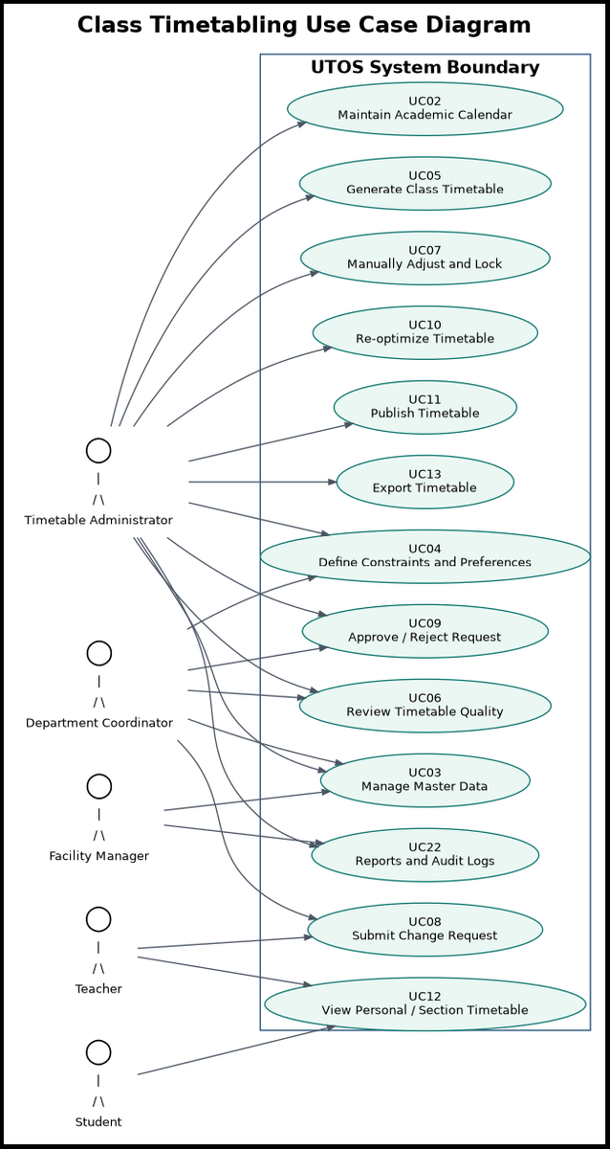
Figure 3: Class Timetabling Use Case Diagram - generation, review, change requests, publication, and reports.
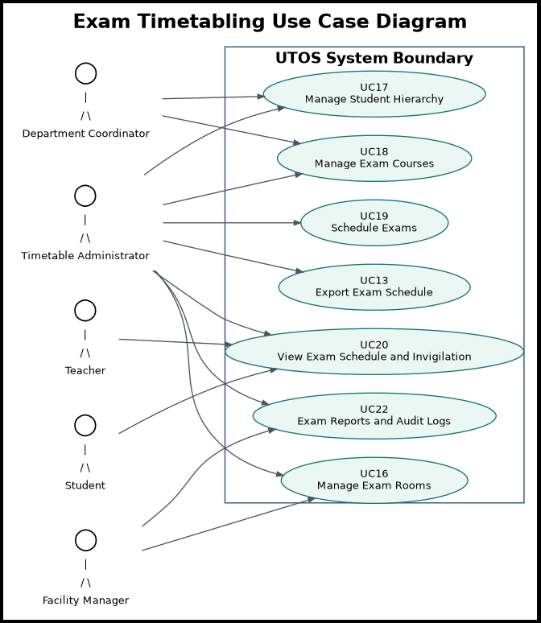
Figure 4: Exam Timetabling Use Case Diagram - exam rooms, hierarchy, courses, scheduling, invigilation, and export.
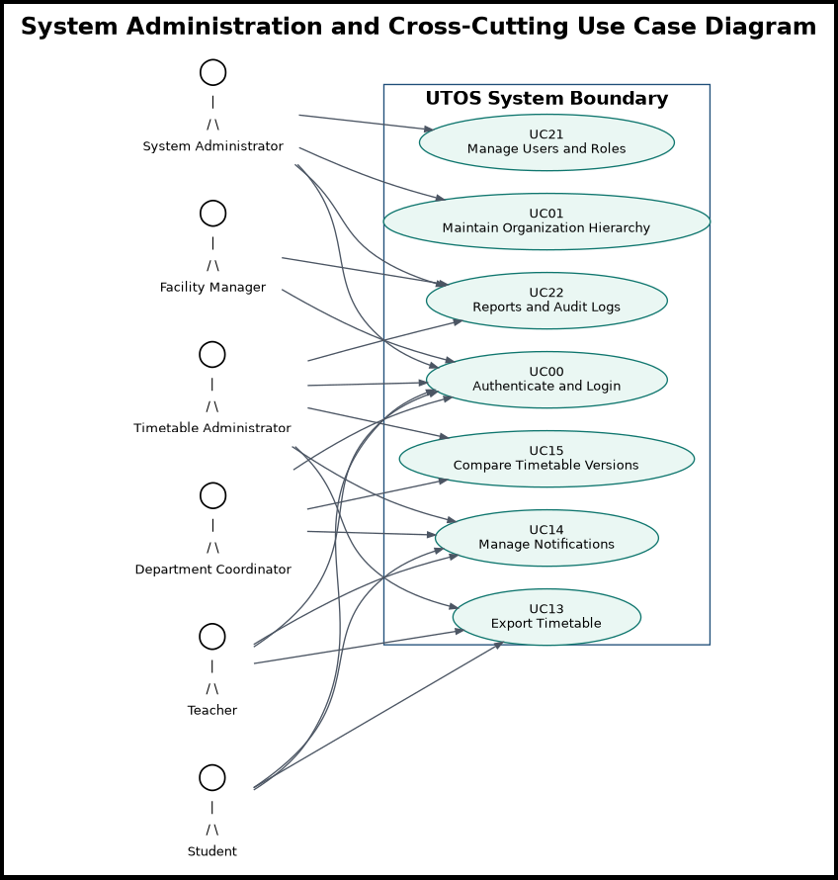
Figure 5: System Administration and Cross-Cutting Use Case Diagram - login, hierarchy, notifications, versioning, export, users, and audit logs.

9. System Modeling and Diagram Review

9.1 DFD Level 0 - Context Diagram
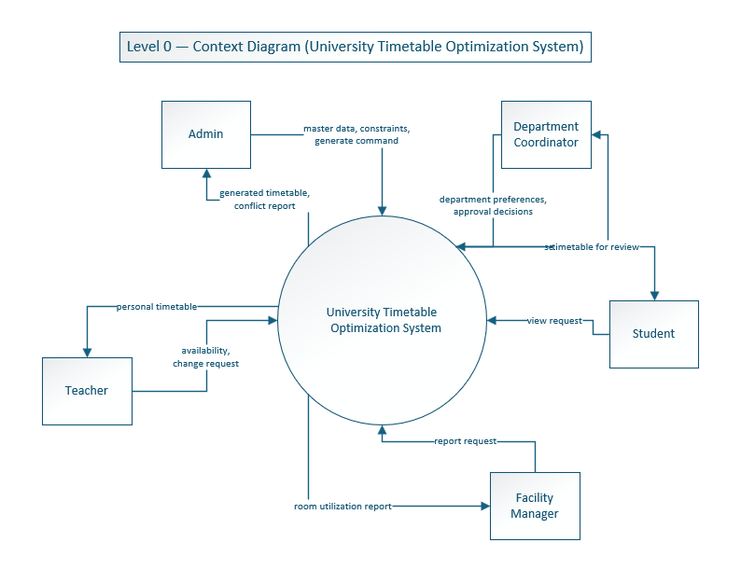
Figure 6: DFD Level 0 - UTOS context diagram showing external actors and main data flows.

9.2 DFD Level 1
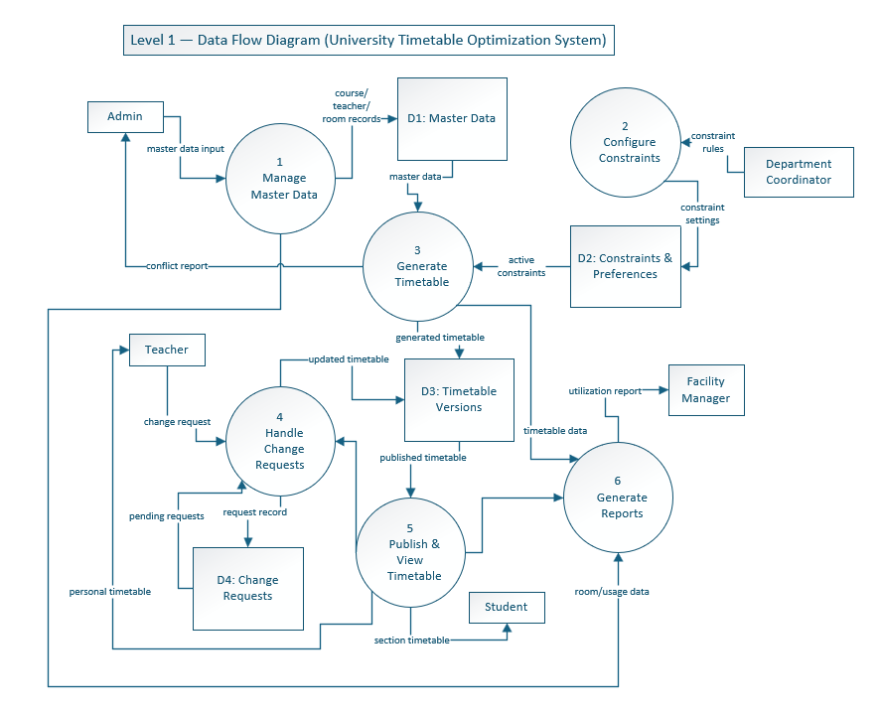
Figure 7: DFD Level 1 - major processes for master data, constraints, generation, requests, publication, reports, and exams.

9.3 DFD Level 2 - Generate Timetable
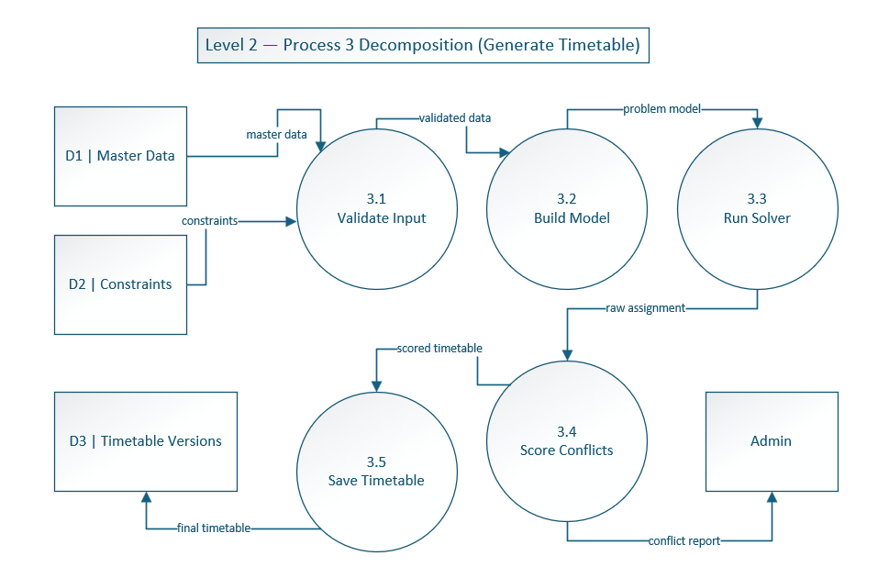
Figure 8: DFD Level 2 - decomposition of Generate Timetable into validation, model building, solver run, conflict scoring, and saving.

9.4 Swimlane Diagram
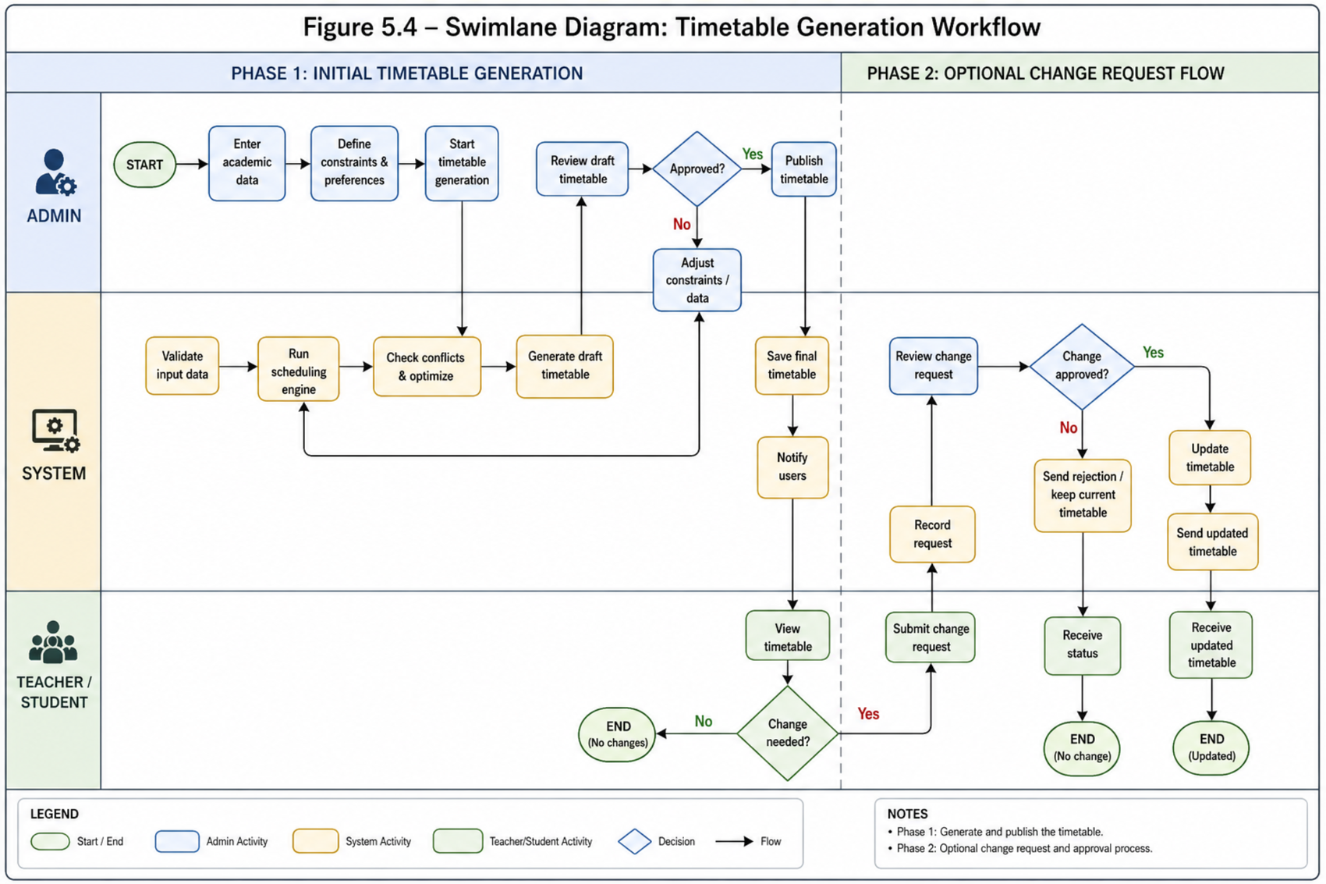
Figure 9: Swimlane diagram - initial timetable generation and optional change request flow.

9.5 System Sequence Diagram
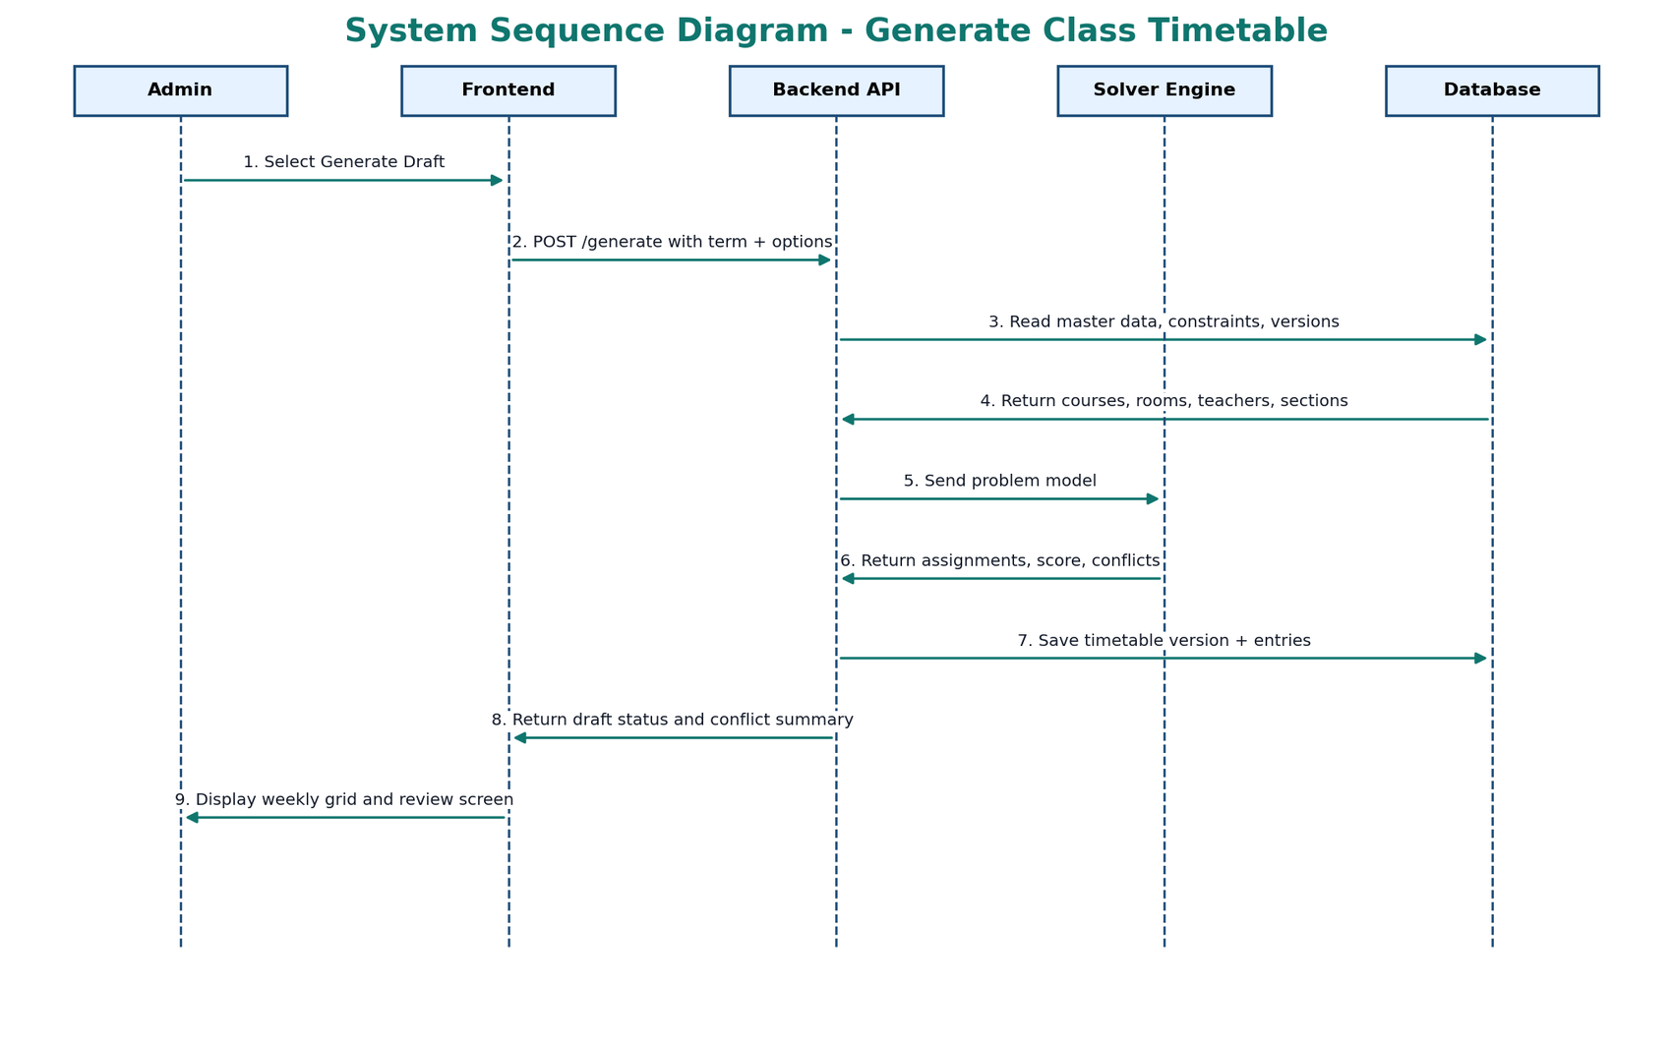
Figure 10: System Sequence Diagram - Generate Class Timetable.

9.6 ERD / Domain Model
The full-scope data model includes timetable versions, notifications, audit logs, exam sessions, invigilation assignments, organization hierarchy, and distance graph entities. This is stronger than keeping version as only a field inside a timetable entry.
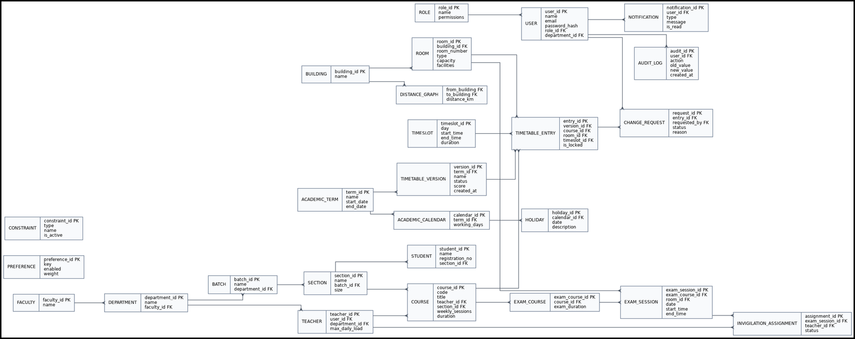
Figure 11: Full-scope ERD / domain model for UTOS.

9.7 Architecture Diagram
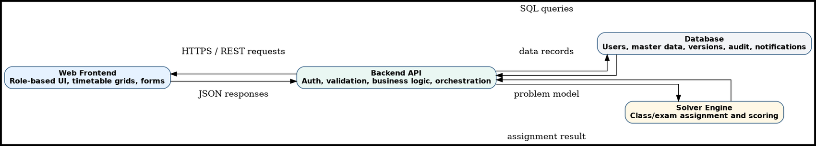
Figure 12: Clean architecture diagram - frontend, backend API, database, and solver engine.

10. UI Screenshots and Real Use Case Evidence
The following image galleries collect the supplied UI screenshots and connect them to the real use case descriptions. They show role-based navigation, timetable workflow screens, master data management, change request handling, and reports.
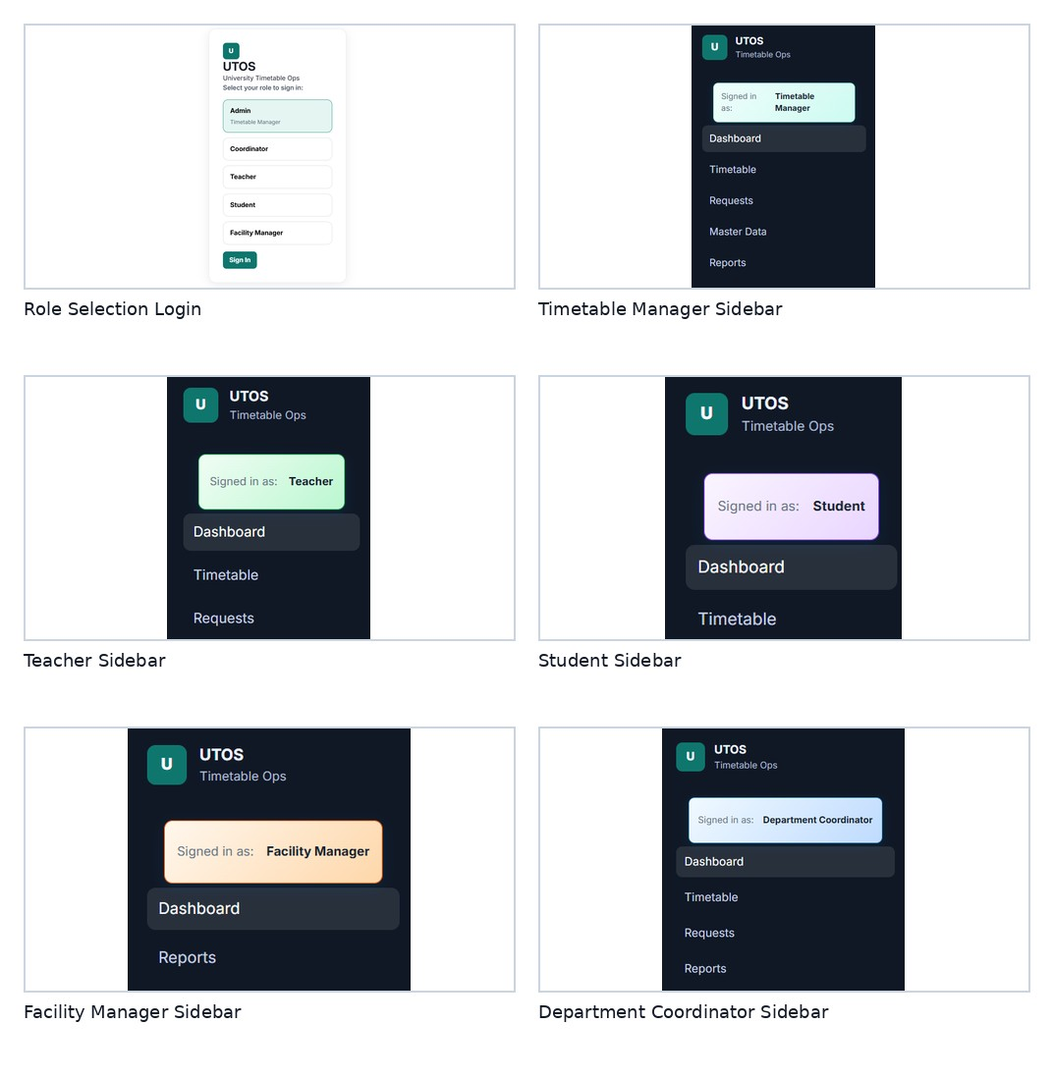
Figure 13: UI Evidence Gallery - role-based login and role-specific navigation.
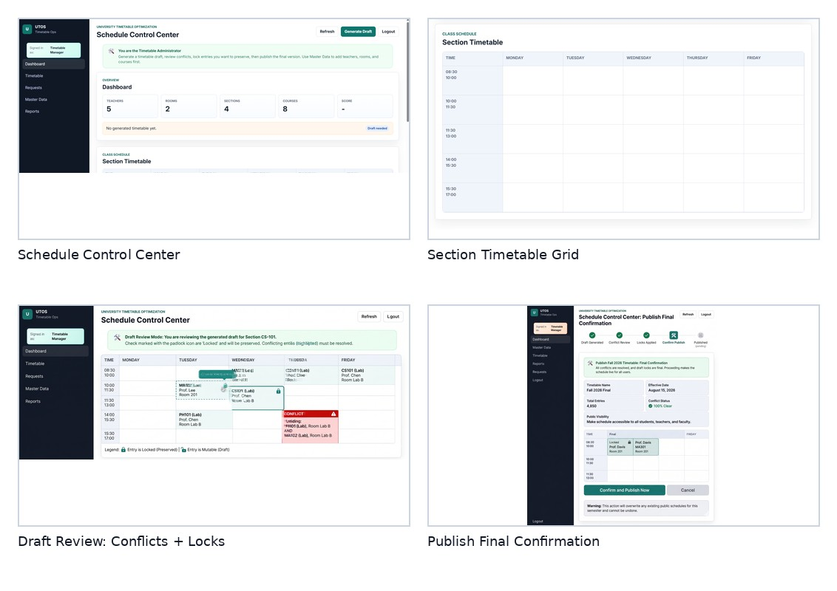
Figure 14: UI Evidence Gallery - dashboard, timetable grid, draft review, and publish confirmation.
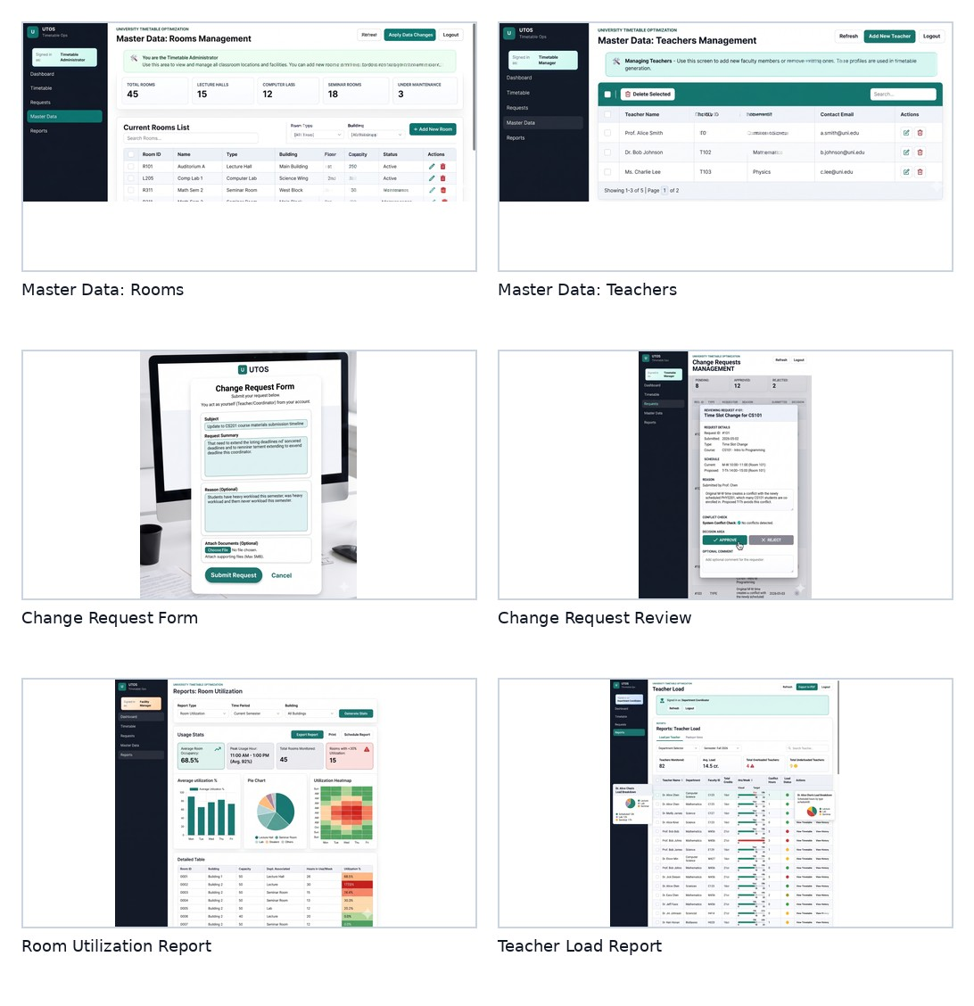
Figure 15: UI Evidence Gallery - master data, change requests, room utilization, and teacher load reports.

11. Traceability Matrix
Use Case | Name | SRS Reference | Evidence
UC00 | Authenticate and Login | FR-00.1 to FR-00.6c | High-level use case + expanded use case
UC01 | Maintain Organization Hierarchy | FR-00.6a to FR-00.6d | High-level use case
UC02 | Maintain Academic Calendar | FR-01.1 to FR-01.5 | High-level use case
UC03 | Manage Master Data | FR-02.1 to FR-02.6b; FR-15.1 to FR-15.4 | High-level use case + expanded use case
UC04 | Define Constraints and Preferences | FR-03.1 to FR-03.15 | High-level use case
UC05 | Generate Class Timetable | FR-04.1 to FR-04.7c | High-level use case + expanded use case
UC06 | Review Timetable Quality | FR-05.1 to FR-05.5; FR-21.1 to FR-21.8 | High-level use case + expanded use case
UC07 | Manually Adjust and Lock Timetable | FR-06.1 to FR-06.4 | High-level use case
UC08 | Submit Change Request | FR-10.1 to FR-10.3 | High-level use case + expanded use case
UC09 | Approve or Reject Change Request | FR-10.2 to FR-10.3 | High-level use case + expanded use case
UC10 | Re-optimize Timetable | FR-07.1 to FR-07.3 | High-level use case + expanded use case
UC11 | Publish Timetable | FR-08.1 to FR-08.4b | High-level use case + expanded use case
UC12 | View Personal or Section Timetable | FR-09.1 to FR-09.3 | High-level use case
UC13 | Export Timetable | Export FR-00.1 to FR-00.5b | High-level use case
UC14 | Manage Notifications | Notifications FR-00.6 to FR-00.14 | High-level use case
UC15 | Compare Timetable Versions | FR-00.15 to FR-00.19 | High-level use case
UC16 | Manage Exam Rooms | FR-15.1 to FR-15.4 | High-level use case
UC17 | Manage Student Hierarchy | FR-16.1 to FR-16.4; FR-20.6 to FR-20.8 | High-level use case
UC18 | Manage Exam Courses | FR-17.1 to FR-17.3 | High-level use case
UC19 | Schedule Exams | FR-18.1 to FR-18.8 | High-level use case + expanded use case
UC20 | View Exam Schedule and Invigilation Duties | FR-19.1 to FR-19.5 | High-level use case
UC21 | Manage Users and Roles | FR-20.1 to FR-20.8 | High-level use case + expanded use case
UC22 | View System Reports and Audit Logs | FR-21.1 to FR-21.8 | High-level use case + expanded use case

12. Final Modeling Notes, Conclusion, and Checklist

12.1 Modeling Notes
- Use cases are based on actor goals, not database tables or individual UI buttons.
- Essential and real use cases are separated according to the Analysis Models guidance.
- The full-scope SRS is reflected through system-wide, class, exam, administration, reporting, and audit use cases.
- The use case diagrams are split to avoid overcrowding.
- The ERD includes full-scope entities for versions, notifications, audit logs, exam sessions, and hierarchy.
- UI screenshots are treated as real-use-case evidence, while features not yet shown in UI remain documented as SRS requirements for later increments.

12.2 Conclusion
This improved document presents UTOS as a full-scope University Timetable Optimization and Management System. It aligns with the full SRS, upgrades the use case analysis using the teacher-provided essential/real/expanded use case style, updates diagrams, and includes UI evidence showing how the requirements appear in the current prototype.

12.3 Submission Checklist
Item | Status
Full-scope SRS alignment | Included
High-level use cases UC00-UC22 | Included
Expanded essential and real use cases | Included for core flows
Use case diagrams | Class, Exam, and System diagrams included
DFD Level 0, Level 1, Level 2 | Included
Swimlane and sequence diagrams | Included
ERD / domain model | Included
Architecture diagram | Included
UI screenshots | Included as galleries
Traceability matrix | Included

References / Source Materials Used
- SRS_v1.0_Full_Scope.md - main source of truth for scope and requirements.
- 04 Analysis-Models.ppt - use case analysis style, essential/real distinction, and expanded use case format.
- UTOS draft documents - earlier class-timetable project baseline.
- Provided UI screenshots and diagrams - real use case evidence and system modeling support.

